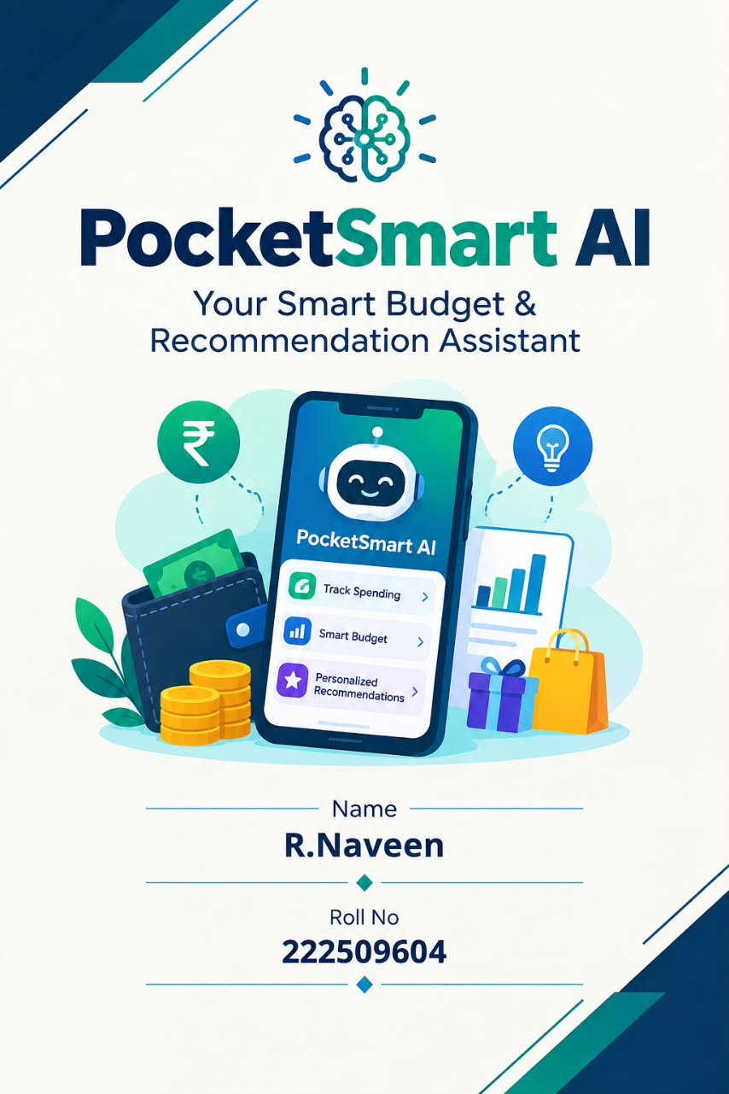
---

*PROJECT TITLE: HealthSpend AI - Your Medical & Lifestyle Budget Assistant*

*ABSTRACT*
People spend a lot on unhealthy habits without knowing it. HealthSpend AI is a smart assistant that tracks both health-related expenses and lifestyle spending. It not only shows how much you spend on smoking, alcohol, fast food, and medical bills, but also uses AI to give health + money saving advice. Eg: "You spent Rs.3000 on smoking this month, if you stop you can save Rs.36,000 per year and improve lung health". It combines finance + health awareness.

*INTRODUCTION*
Today youth spends on Swiggy, smoking, vapes, energy drinks, and then spends again on doctor/hospital. HealthSpend AI breaks this cycle. It tracks unhealthy spending and medical spending together and gives AI-driven advice to save money and stay healthy.

*PROBLEM STATEMENT*
- Students spend on smoking, alcohol, fast food without tracking
- No app shows connection between lifestyle and medical expenses
- Medical bills are unexpected and not budgeted
- No personalized health + finance advice

*OBJECTIVE*
- To track lifestyle expenses (smoking, fast food, alcohol, vapes)
- To track medical expenses (doctor, medicines, gym, healthy food)
- AI to calculate: "If you quit this habit, how much money & health you save"
- To give healthy cheaper alternatives (Home food vs Swiggy)
- Chatbot to answer health-budget questions

*SYSTEM ARCHITECTURE*
USER INPUT (Daily habit: Cig 2, Swiggy 1, Medicine Rs.200) -> DATABASE -> AI ENGINE
(Gemini analyzes: Unhealthy 70%, Medical 30%) -> RECOMMENDATION -> OUTPUT: Health Score + Savings Plan + Alert

*MODULES*

_Module 1: Lifestyle Expense Tracker_
User enters: Smoking Rs.100/day, Fast food Rs.200, Vape Rs.150. Dashboard shows pie chart: 60% money goes to unhealthy habits.

_Module 2: Medical Expense Tracker_
Doctor fees, Tablet bills, Gym fees, Healthy groceries. System compares: Unhealthy Spend vs Healthy Spend.

_Module 3: AI Health + Wealth Engine (MAIN MODULE)_
Gemini API Prompt: "User spent Rs.3000 on smoking, Rs.4000 on Swiggy, Rs.1000 on medicines. Give health risk and savings advice" AI Output:
"Da Tharun, un lung health ku risk. Smoking niruthina varushathuku 36k save pannalam + gym join pannalam. Swiggy ku badhila veetla samacha 2500 save + health improve" Calculates Yearly Savings if habit stopped.

_Module 4: AI Chatbot - Dr. Budget_
User: "Daily 2 cigarette kudikiren, enna aagum?"
AI: "Month 1800 waste + health risk. Niruthina 1 year la 21k save, adha vechu 6 months gym pogalam"
User: "Fever ku evlo budget venum?" AI gives budget plan.

*TECH STACK*
Same as Pocket Smart: Python Flask, HTML/CSS/JS, SQLite, Gemini API, Pandas, Matplotlib, http://Chart.js

*ADVANTAGES*
- Unique combo of Health + Finance - no other app does this
- Social impact project - examiner will love
- Saves money + improves health
- Student-friendly, awareness creating
- Can collaborate with college NSS, Health dept

*FUTURE SCOPE*
- Tamil Voice: "Thambi, smoking niruthu da"
- Connect to smartwatch for health data
- UPI auto-track for medical shops
- Doctor appointment booking integration
- AI Diet Plan on budget

*CONCLUSION*
Health Spend AI proves AI can be used for both financial wellness and physical wellness. It makes students realize their small unhealthy habits cost huge money. This project has high real-world value and start up potential in health-tech.

*REFERENCE*
Same + WHO health expenditure reports

---

